**LAB MANUAL 8**

**ABDUL RAFEH**

**417648**

**SECTION C**

**LAB TASK:**

**PROGRAM 1:**

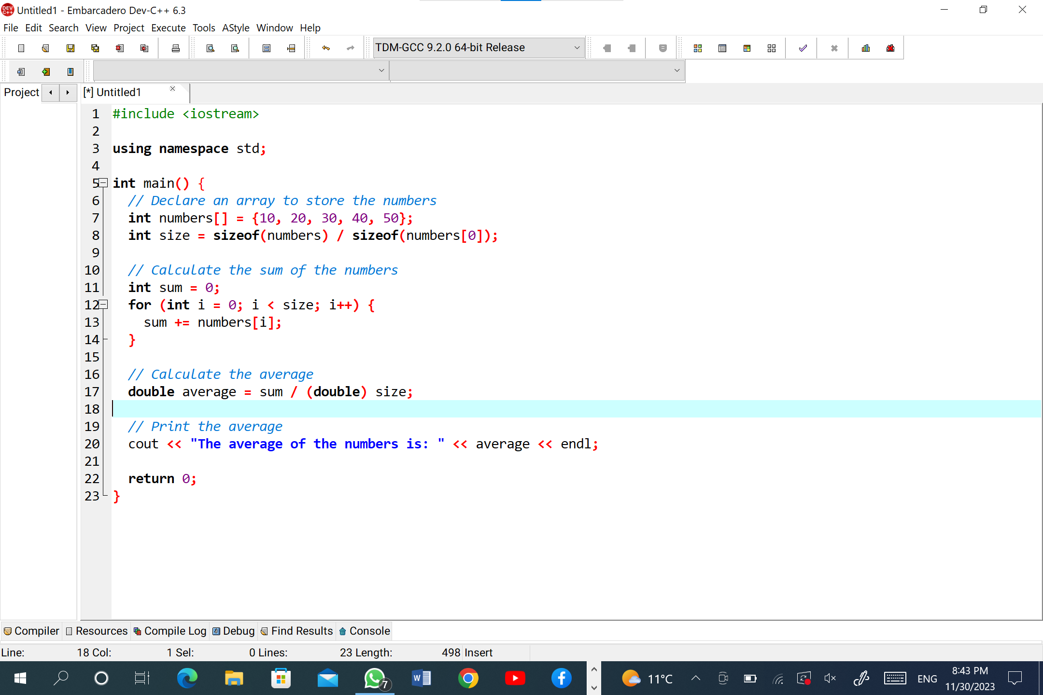

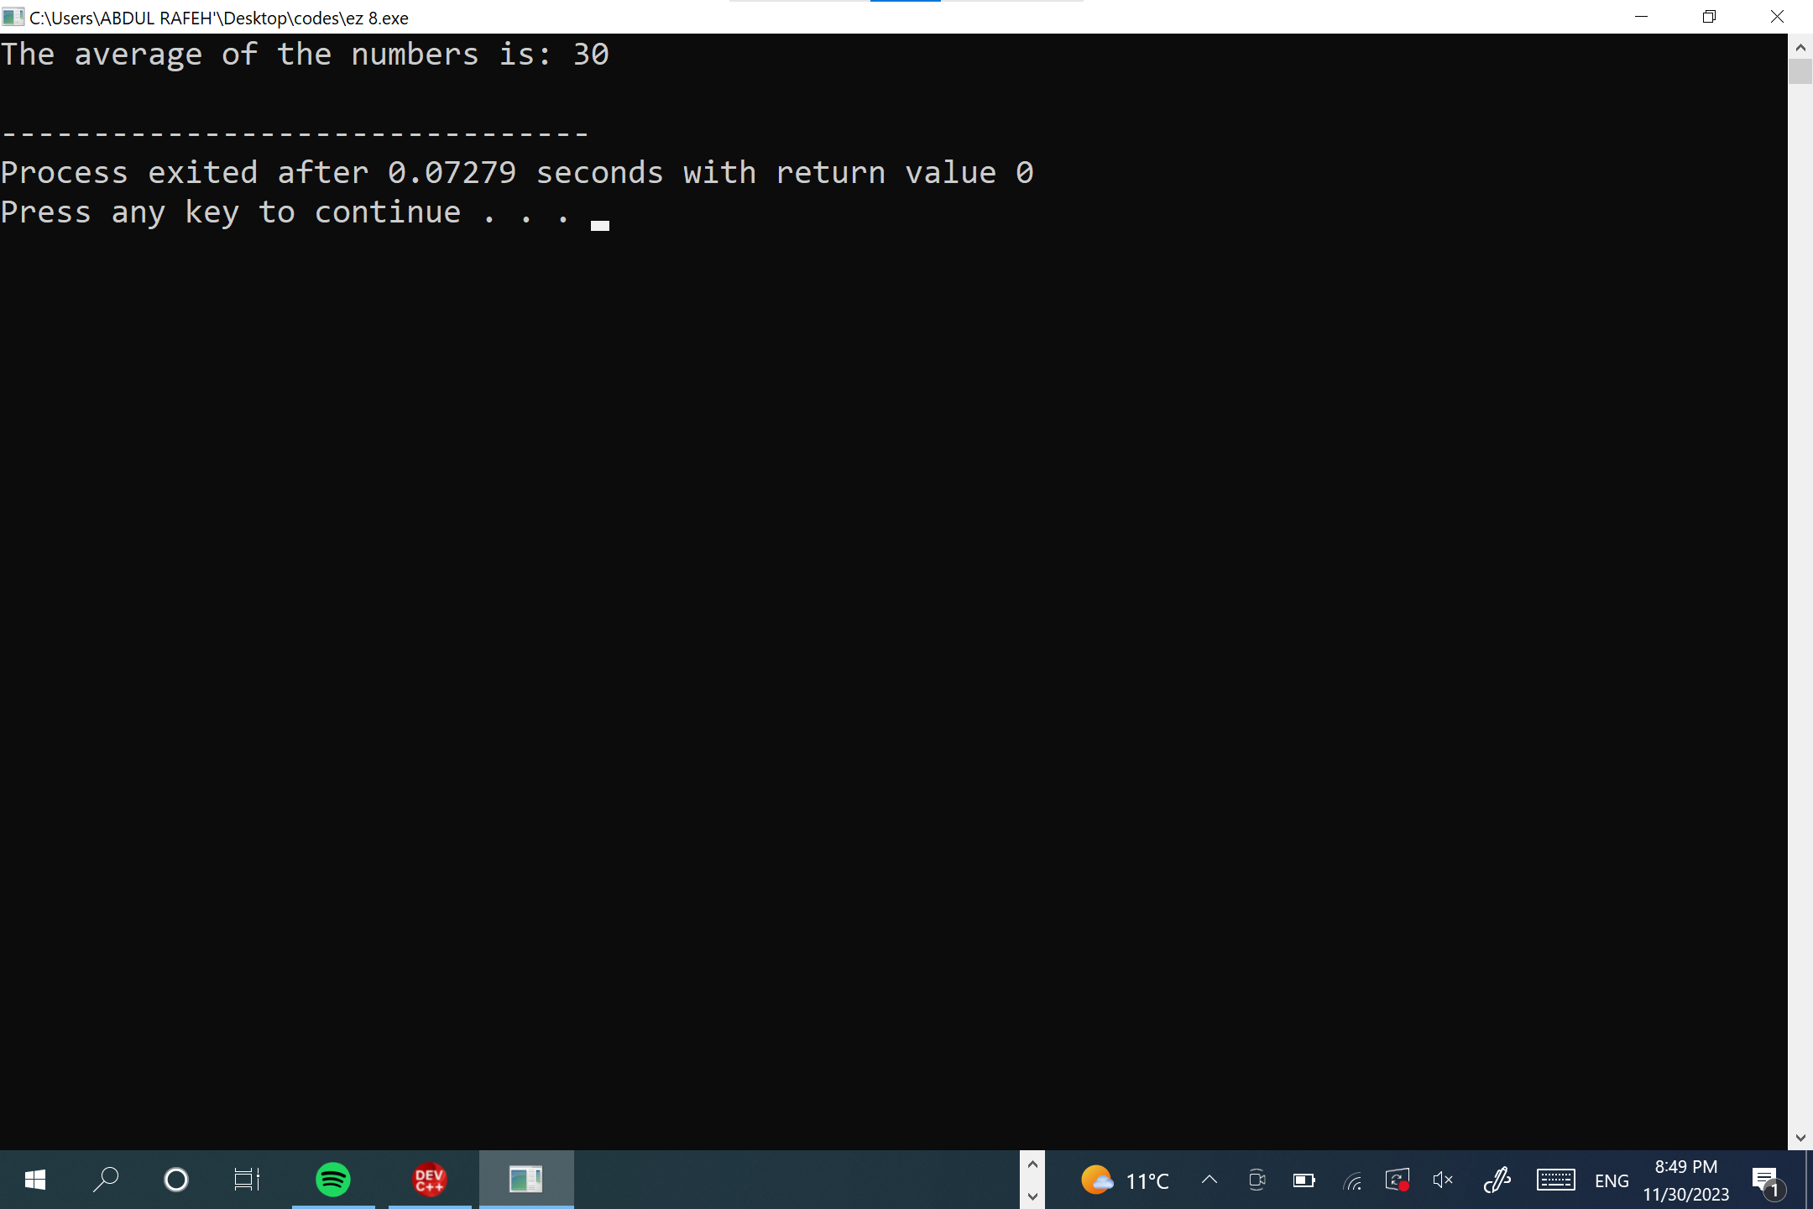

**PROGRAM 2:**

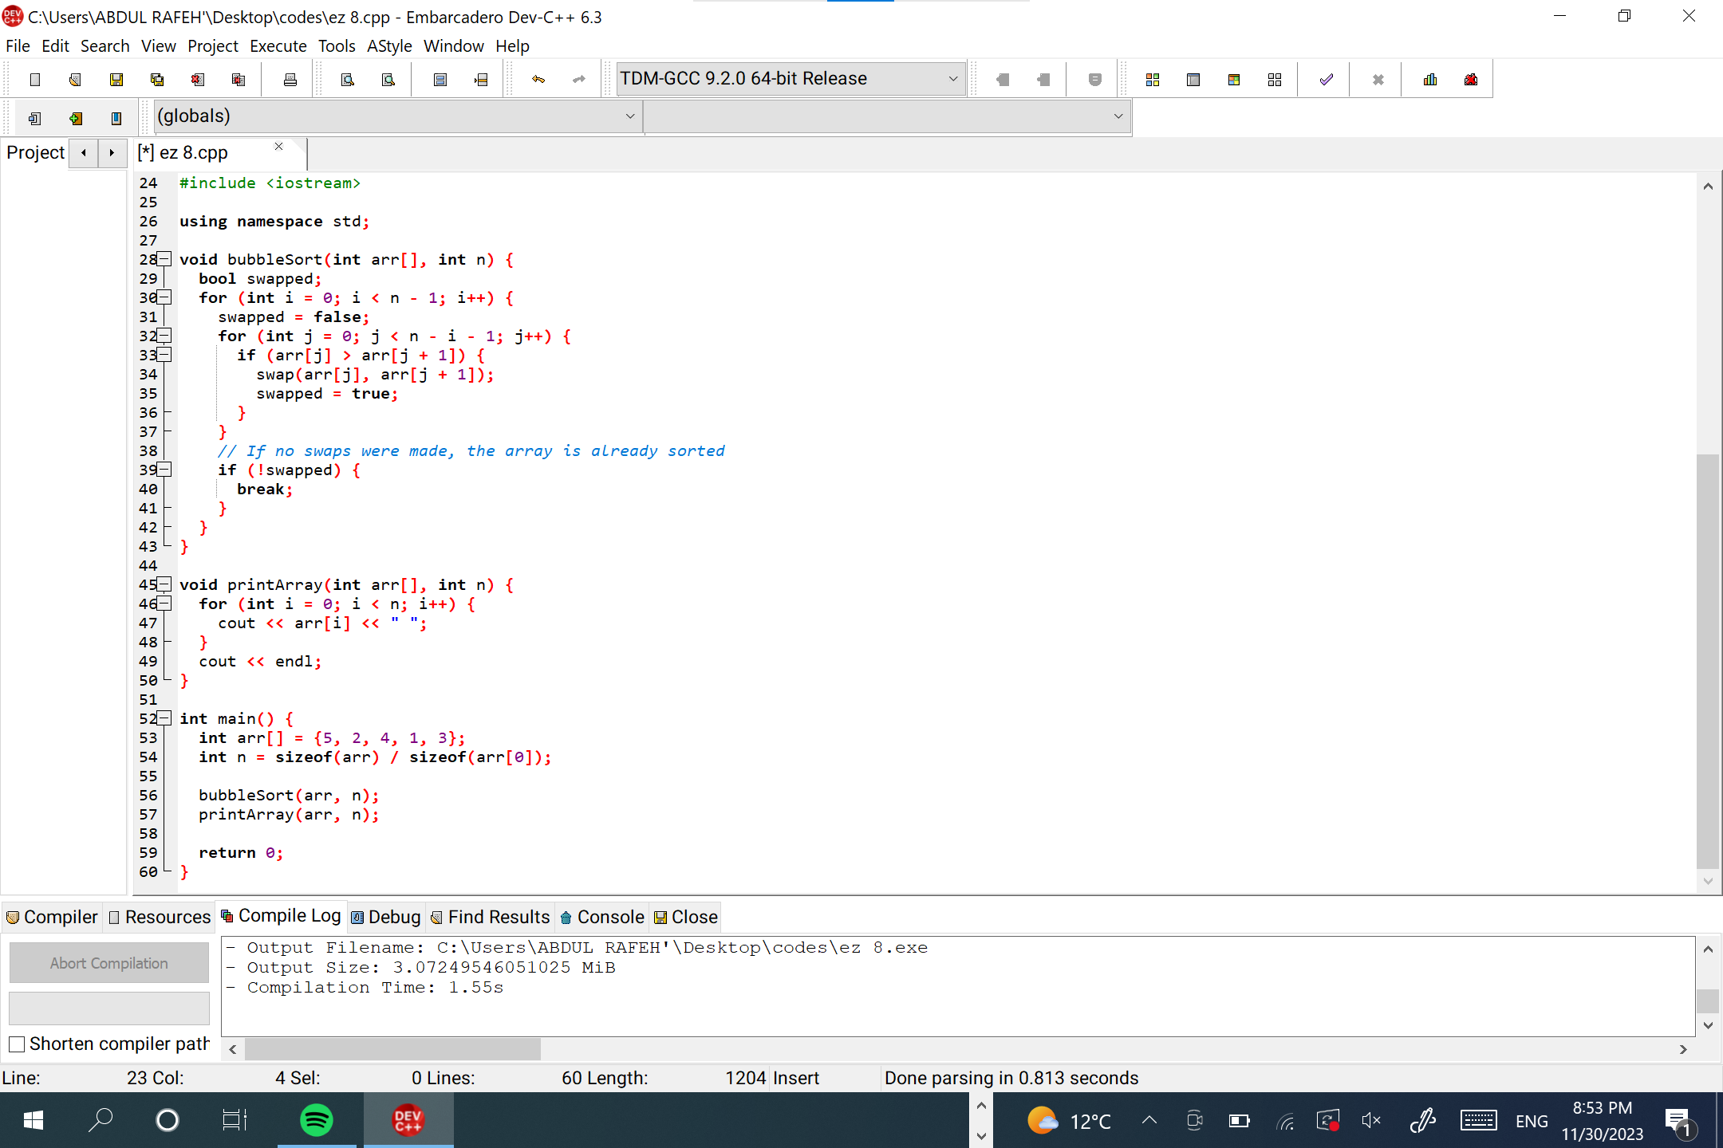

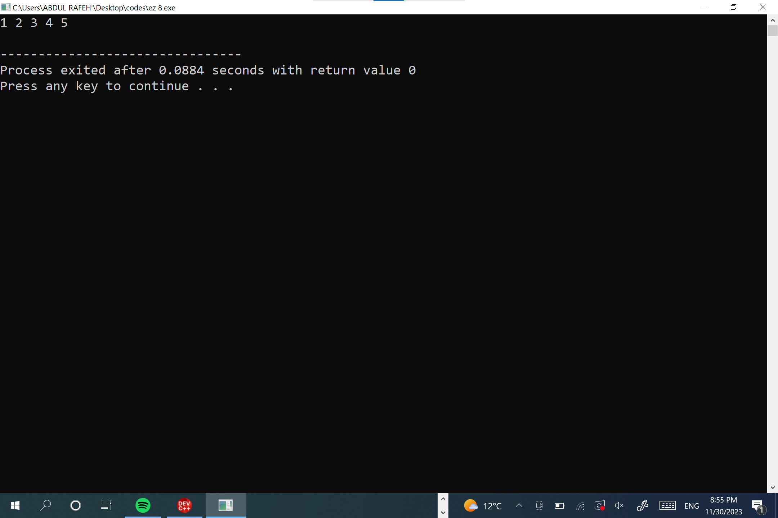

**PROGRAM 3:**

